PROJECT 1
MATH 5900 – ADVANCED DATA ANALYSIS
February 14, 2024
TAIWO JEGEDE
E00755963

PART 1
- CONSTANT VARIANCE ASSUMPTION
The constant variance assumption is also called Homoscedasticity, and it implies that the error terms in a specific regression model, is going to have the same variance across all the predictor variables (Zach, 2021). So the spread of residuals around the regression line is always consistent. this assumption is actually important because it takes note of the standard errors of our regression coefficients and it makes sure that they are unbiased and reliable. So when the assumption is not met or it is violated, then the error terms is said to have heteroscedasticity, and this is because they have different variances across different predictor variables, unlike when it is constant across all the predictor variables. Using a scatter plot can let us see if the variances are constant across all the predictor variables.
- NORMAL PROBABILITY PLOT
A normal probability plot is a graphical representation technique we use in knowing whether the data is normally distributed or not. When we want to plot a normal probability plot, we usually plot the data values against the quantiles of a theoretical normal distribution (Stephanie, 2013). So after we plot, we then check and observe each data points, if there is deviation from the straight line then we can say that there is a depature from normality. When we interpret plots of a normal probability, we observe each data points as said earlier, now some of these data points may be outliers but with the help of visualization and this interpretations we're able to detect and denote all key observations made.

- HOW COEFFICIENTS ARE INTERPRETED IN A LOGISTIC REGRESSION MODEL
One important parameter in a logistic regression model are the coefficients. The coefficients simply represent the log-odds (sometimes called the "logit") of the response variable that we have associated with a one-unit change in the predictor variable (they could be continuous or categorical), while holding other variables constant. The ratio of the likelihood that an event will occur to the likelihood that it won't is known as the log-odds, or natural logarithm of the odds (Zach, 2023).
So basically, when there is a change in the log-odds of the predictor variable, we are able to know because of the coefficients. And to interpret the coefficients in respect of the odds, we can use the formula e^β, where β is the coefficient, and what this does is to provide us with the odds ratio, which is the multiplicative factor that modifies the probabilities in response to a predictor variable increase of one unit.
For example, e^0.5 = 1.65 tells us that while holding other factors constant, the odds of the outcome occurring are 1.65 times higher when X is 1 than when X is 0. This is true if the coefficient for a binary predictor variable, X, is 0.5.
- HOW COEFFICIENTS ARE INTERPRETED IN A COUNT REGRESSION MODEL
When one unit increases the predictor variable in a count regression model, like the Poisson or negative binomial, the coefficients show how the predicted value of the outcome variable (the count) changes while keeping the other variables constant. So lets say that the coefficient for a continuous predictor variable is 0.2, then e^0.2 = 1.22, what we're trying to say is that the expected count of the response variable increases by 22% for every one-unit increase in the predictor variable, holding other predictors constant.

PART II
PURPOSE OF THE ANALYSIS
Penguins are a group of aquatic, flightless birds that live mostly in the Southern Hemisphere, especially in Antarctica, having black and white feathers that help them blend in with the water and the ice, and they have flippers that allow them to swim fast and dive deep. Penguins are social animals that form colonies and cooperate in raising their young. Penguins are also very adaptable and can survive in various climates, from the cold Antarctic to the warm Galapagos Islands. I think everyone likes penguins just because of our fascinating of a creature they are having so many unique behaviors and features.
DESCRIPTION OF THE DATA
The dataset that will be used in my project comprises observations of penguins from different islands, with recorded measurements of bill length, bill depth, flipper length, body mass, and sex. The data were collected through direct observation and measurement of penguins in their natural habitats, and made available in a course I am currently taking.
The data contains columns like Species, which will be the response variable, the Island, bill length, bill depth, flipper length, body mass, and the gender of the penguins.
The variables to be used include:
- Species (response variable): Nominal categorical variable indicating the species of penguins (e.g., Adelie, Gentoo, Chinstrap).
- Island: Nominal categorical variable indicating the island where the penguins were observed.
- Bill length (mm): Numeric variable representing the length of the penguin's bill.
- Bill depth (mm): Numeric variable representing the depth of the penguin's bill.
- Flipper length (mm): Numeric variable representing the length of the penguin's flipper.
- Body mass (g): Numeric variable representing the body mass of the penguin.
PROPOSED ANALYSES
In the suggested analysis, morphological and environmental characteristics are used to create a logistic regression model that predicts the species of penguins. Our goal is to pinpoint the major elements influencing the patterns of species distribution by analyzing the correlation between predictor variables and penguin species. To evaluate the model's performance and confirm its validity, additional diagnostic tests such the ROC curve analysis, deviance residuals analysis, and Hosmer-Lemeshow test will be performed.
Logistic Regression Model:
Log(1-P(Species=Adelie)/P((Species=Adelie) = β0​ +β1​×Bill_Length_mm+β2​×Bill_Depth_mm+β43×Flipper_Length_mm+β4​×Body_Mass_g
ANALYSIS RESULTS
After fitting in the model, we did descriptive statistic check to check how well our model performed. Below are the results.
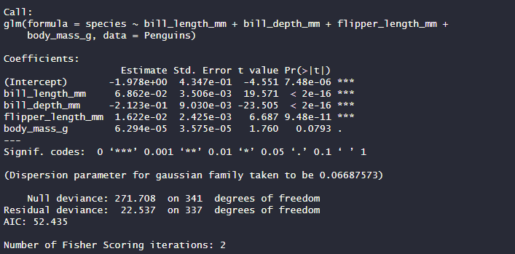
Our model is given by:
log(1−P(Species=Adelie)/P(Species=Adelie))=−1.978+0.0682×bill_length_mm−0.2123×bill_depth_mm+0.0162×flipper_length_mm+0.00006294×body_mass_g
Interpretation:
Intercept: In our model, the intercept is -1.978, which means that when all predictor variables are zero, the log-odds of the reference category (likely Adelie species if it's the first level) is -1.978.
bill_length_mm: For every one-unit increase in bill length (in millimeters), the log-odds of the penguin species being in the category of interest (e.g., Adelie, Gentoo, Chinstrap) increases by 0.0682.
bill_depth_mm: For every one-unit increase in bill depth (in millimeters), the log-odds of the penguin species being in the category of interest decreases by 0.2123.
flipper_length_mm: For every one-unit increase in flipper length (in millimeters), the log-odds of the penguin species being in the category of interest increases by 0.0162.
body_mass_g: For every one-unit increase in body mass (in grams), the log-odds of the penguin species being in the category of interest increases by 0.00006294.
After fitting my model, I went on to evaluate the newly fitted logistic regression model using test like the Hosmer-Lemeshow to test the goodness of fit, the deviance residuals to detect outliers or influential observations, and ROC curve analysis to evaluate model discrimination and determine the area under the curve (AUC).
Hosmer-Lemeshow test
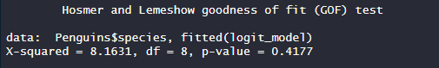
After getting the result from our test, the null hypothesis for the Hosmer-Lemeshow test is that the model fits the data well, i.e., there is no significant difference between the observed and expected values. Since the p-value (0.4177) is greater than the significance level (typically 0.05), we fail to reject the null hypothesis. This indicates that there is no significant difference between the observed and expected values, and thus, the logistic regression model fits the data well according to the Hosmer-Lemeshow test.

The ROC Curve and Area under the curve:
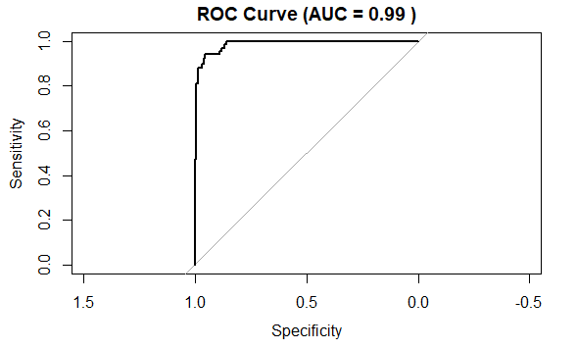
If we look at our plot above, we can see that the ROC curve plot visually confirms this high discrimination ability, as it hugs the upper-left corner of the plot, indicating excellent performance.
The area under the curve:
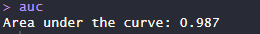
The logistic regression model appears to have good discriminating power because the AUC value is near to 1. So I can say the model performs a fantastic job at differentiating between the many kinds of penguins using the variables that are provided.

CONCLUSION
In summary, the goal of our investigation was to use logistic regression to identify the species of penguins based on their physical characteristics and their surroundings. First, we verified that the logistic regression model satisfied its assumptions. The results showed that the model fitted the data quite well. The model's good fit was confirmed by the Hosmer-Lemeshow test, which indicated that there was no discernible difference between the observed and anticipated values. Furthermore, it was discovered that the model's area under the ROC curve (AUC) was remarkably high at 0.987, showing outstanding discrimination capacity in differentiating between the penguin species.
REFERENCES
Zach. (2021, September 13). The Constant Variance Assumption: Definition & Example. Statology. https://www.statology.org/constant-variance-assumption/
Zach. (2023, April 17). How to Interpret Logistic Regression Coefficients (With Example). Statology. https://www.statology.org/interpret-logistic-regression-coefficients/
Stephanie. (2013, September 11). Normal Probability Plot: Definition, Examples. Statistics How To. https://www.statisticshowto.com/normal-probability-plot/
PBS. “Penguin Fact Sheet | Blog | Nature | PBS.” Nature, 8 Apr. 2021, www.pbs.org/wnet/nature/blog/penguin-fact-sheet/.
APPENDIX
CODE
setwd('C:/Users/student75/Desktop/Assignements and Project/MATH5900/Project 1')
Penguins = read.csv('penguins.csv')
View(Penguins)
# Load necessary libraries
library(ggplot2)
library(dplyr)
library(pROC)
# Drop the 'sex' column
Penguins <- select(Penguins, -sex)
# Check for missing values
sum(is.na(Penguins))

# Remove rows with missing values
penguins <- na.omit(Penguins)
Penguins <- Penguins[complete.cases(Penguins), ]
# Explore the structure of the dataset
str(Penguins)
# Check the first few rows of the dataset
head(Penguins)
# Check the levels of the response variable (species)
table(Penguins$species)
# Convert 'species' to a factor variable
Penguins$species <- factor(Penguins$species)
# Encode 'species' into binary values
Penguins$species <- as.numeric(Penguins$species) - 1
# Fit a logistic regression model without splitting the data
logit_model <- glm(species ~ bill_length_mm + bill_depth_mm + flipper_length_mm + body_mass_g, data = Penguins)
# Summary of the logistic regression model
summary(logit_model)

# Scatterplot of fitted values vs. residuals
plot(logit_model$fitted.values, residuals(logit_model),
xlab = "Fitted values", ylab = "Residuals",
main = "Residuals vs. Fitted values")
# Plot residuals vs. row number
plot(residuals(logit_model) ~ 1:nrow(Penguins),
xlab = "Row number", ylab = "Residuals",
main = "Residuals vs. Row number")
# Plot deviance residuals
plot(predict(logit_model, type = "response"),
residuals(logit_model, type = "deviance"),
xlab = "Fitted values", ylab = "Deviance residuals",
main = "Deviance Residuals vs. Fitted values")
library(ResourceSelection)
# Hosmer-Lemeshow test for goodness-of-fit
hoslem.test(Penguins$species, fitted(logit_model))

# Predict the species of penguins on the entire dataset
predictions <- predict(logit_model, type = "response")
# ROC curve analysis
roc <- roc(penguins$species, fitted(logit_model))
auc <- auc(roc)
auc
plot(roc, main = paste("ROC Curve (AUC =", round(auc, 2), ")"))

